CodeAlpha Internship Task Report
- Introduction
This report contains three simple Python projects developed as part of the internship tasks. These programs demonstrate basic programming concepts such as loops, conditions, random functions, and user interaction.
- Project 1: Simple Chatbot
Objective:
To create a basic chatbot that responds to user input using predefined rules.
Code:
Python
Print(“Simple Chatbot”)
Print(“Type ‘bye’ to exit”)

While True:
User = input(“You: “).lower()

If user == “hello”:
Print(“Bot: Hi!”)
Elif user == “how are you”:
Print(“Bot: I am fine, thanks!”)
Elif user == “what is your name”:
Print(“Bot: My name is ChatBot.”)
Elif user == “bye”:
Print(“Bot: Goodbye!”)
Break
Else:
Print(“Bot: Sorry, I don’t understand.”)
Working:
Takes user input continuously.
Responds based on predefined conditions.
Stops when user types “bye”.

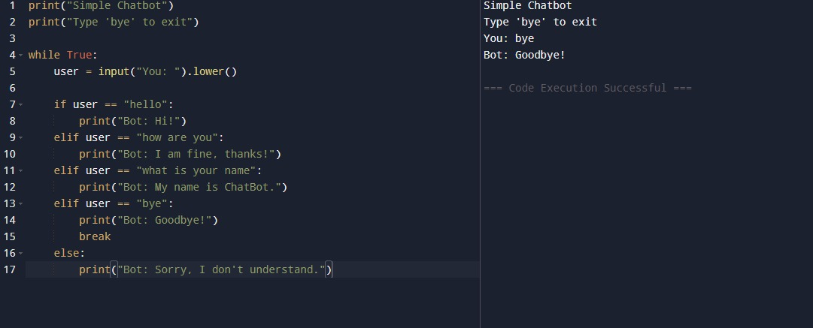

- Project 2: Hangman Game
Objective:
To create a word guessing game where the user guesses letters to find the hidden word.
Code:
Import random
Words = [“apple”, “mango”, “grapes”, “banana”, “orange”]
Word = random.choice(words
Guessed = []
Tries = 6
Print(“Welcome to Hangman!”)
While tries > 0:
Display = “”
For letter in word:
If letter in guessed:
Display += letter + “ “
Else:
Display += “_ “
Print(display)

If “_” not in display:
Print(“Congratulations! You guessed the word:”, word)
Break
Guess = input(“Guess a letter: “).lower()
If guess in word:
Guessed.append(guess)
Print(“Correct!”)
Else:
Tries -= 1
Print(“Wrong! Tries left:”, tries)
If tries == 0:
Print(“Game Over! The word was:”, word)
Working:
Random word is selected.
User guesses letters.
Correct guesses reveal letters.
Wrong guesses reduce attempts.
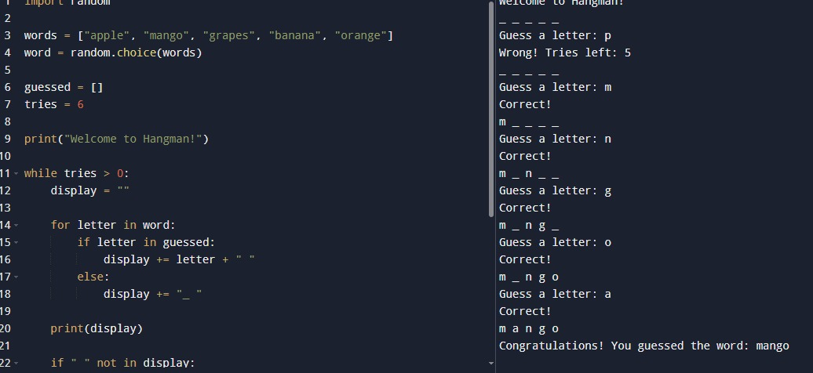

- Project 3: Number Guessing Game
Objective:
To create a simple number guessing game with limited attempts.
Code:
Import random
Print(“Welcome to Number Guessing Game!”)
Print(“I am thinking of a number between 1 and 10”)
Number = random.randint(1, 10)
Tries = 3
While tries > 0:
Guess = int(input(“Enter your guess: “))
If guess == number:
Print(“Congratulations! You guessed the correct number.”)
Break
Elif guess > number:
Print(“Too high!”)
Else:
Print(“Too low!”)
Tries -= 1
Print(“Tries left:”, tries)
If tries == 0:
Print(“Game Over! The correct number was:”, number)
Working:
Random number is generated.
User gets 3 attempts.
Program gives hints (high/low).
Ends when correct or attempts finish.

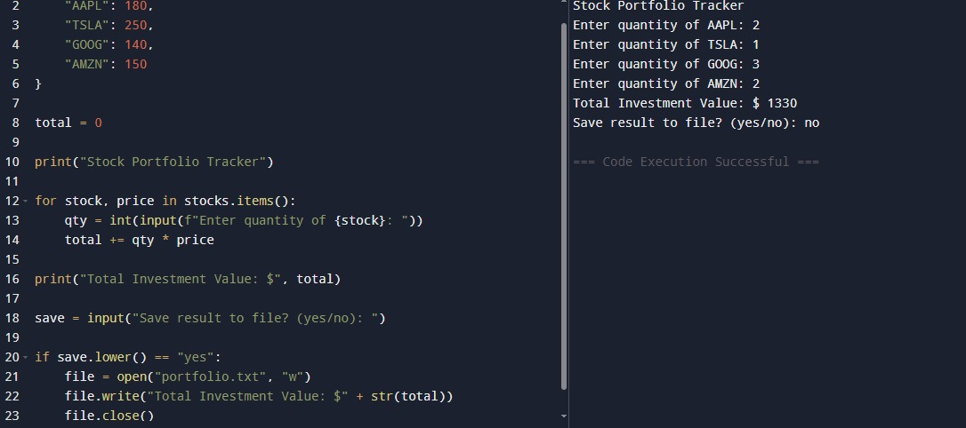

- Conclusion
These three projects helped in understanding basic Python programming concepts such as loops, condition statements, random number generation, and user interaction. They also improved logical thinking and problem-solving skills.

